H168N WirelessVDSL2 Uplink Gateway
H168N is a Wireless and VDSL2 uplink gateway. Comprehensive QoS techniques ensure the simultaneous use of services with a good level of performance. DLNA server enables multimedia contents sharing. The integration of TR-069 technologies facilitates the automatic installation and the automatic provisioning of services.
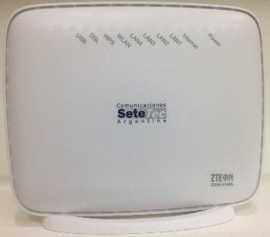
Features
- VDSL wireless modem
- Multimode VDSL2 (up to 17a profile) / ADSL2+
- G.Vector+G.INP to maximize data rate of VDSL
- Dual-Stream 802.11n Wi-Fi up to 300Mbps
- Fast Ethernet 4-port switch
- USB 2.0 for shared storage or 3G Dongle
- Built-in DLNA Digital Media Server
- Robust remote management - TR069
- IPv4/IPv6 Dual Stack and DS-Lite
- CoC Tier 2013-2014
Specifications
Physical Interface | WAN | VDSL2 / ADSL2+
 | LAN | 4 x 10/100M FE  802.11b/g/n Wi-Fi @ 2.4G(2x2)  1 x USB 2.0 Host
Power Consumption | < 10W
Net Weight | 190g
Dimensions(L×W×H) | 146mm×54mm×126mm
Operating Temperature | 0～40℃（32℉～104℉）
Humidity | 5% - 95%

